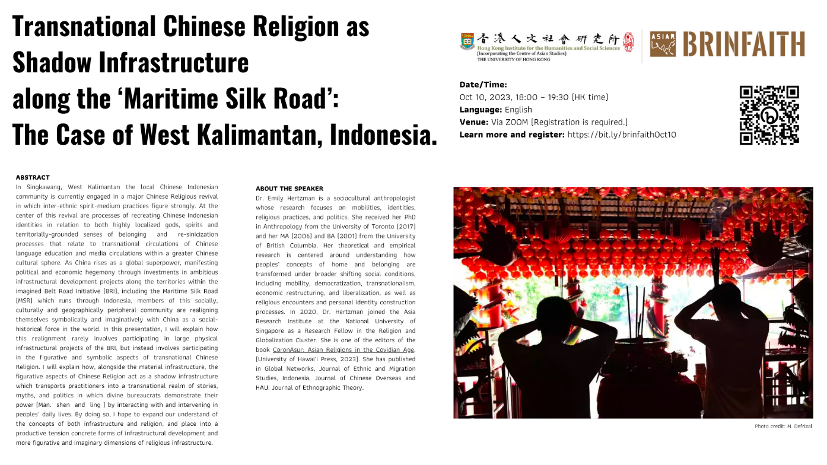

BRINFAITH Religion and Empire Lecture Series

Transnational Chinese Religion as Shadow

Infrastructure along the ‘Maritime Silk Road’:

The Case of West Kalimantan, Indonesia.

Date/Time:
Oct 10, 2023, 18:00 – 19:30 (HK time)
Language: English
Venue: Via ZOOM (Registration is required.)
Learn more and register: https://bit.ly/brinfaithOct10

ABSTRACT
In Singkawang, West Kalimantan the local Chinese Indonesian community is currently engaged in a major Chinese Religious revival in which inter-ethnic spirit-medium practices figure strongly. At the center of this revival are processes of recreating Chinese Indonesian identities in relation to both highly localized gods, spirits and territorially-grounded senses of belonging and re-sinicization processes that relate to transnational circulations of Chinese language education and media circulations within a greater Chinese cultural sphere. As China rises as a global superpower, manifesting political and economic hegemony through investments in ambitious infrastructural development projects along the territories within the imagined Belt Road Initiative (BRI), including the Maritime Silk Road (MSR) which runs through Indonesia, members of this socially, culturally and geographically peripheral community are realigning themselves symbolically and imaginatively with China as a social-historical force in the world. In this presentation, I will explain how this realignment rarely involves participating in large physical infrastructural projects of the BRI, but instead involves participating in the figurative and symbolic aspects of transnational Chinese Religion. I will explain how, alongside the material infrastructure, the figurative aspects of Chinese Religion act as a shadow infrastructure which transports practitioners into a transnational realm of stories, myths, and politics in which divine bureaucrats demonstrate their power (Man. shen and ling) by interacting with and intervening in peoples’ daily lives. By doing so, I hope to expand our understand of the concepts of both infrastructure and religion, and place into a productive tension concrete forms of infrastructural development and more figurative and imaginary dimensions of religious infrastructure.

ABOUT THE SPEAKER
Dr. Emily Hertzman is a sociocultural anthropologist whose research focuses on mobilities, identities, religious practices, and politics. She received her PhD in Anthropology from the University of Toronto (2017) and her MA (2006) and BA (2001) from the University of British Columbia. Her theoretical and empirical research is centered around understanding how peoples’ concepts of home and belonging are transformed under broader shifting social conditions, including mobility, democratization, transnationalism, economic restructuring, and liberalization, as well as religious encounters and personal identity construction processes. In 2020, Dr. Hertzman joined the Asia Research Institute at the National University of Singapore as a Research Fellow in the Religion and Globalization Cluster. She is one of the editors of the book CoronAsur: Asian Religions in the Covidian Age, (University of Hawai’i Press, 2023). She has published in Global Networks, Journal of Ethnic and Migration Studies, Indonesia, Journal of Chinese Overseas and HAU: Journal of Ethnographic Theory.

ORGANIZER
Organizer: ASIAR Research Cluster, HKIHSS, under the RGC Research Fellowship “Chinese Modernity and Soft Power on the Belt and Road”

STAY CONNECTED | Asian Religions, Spirituality and Cultures
Join our mailing list | Twitter@asiarhk | BRINFAITH Website
Enquiry: asiar@hku.hk

